Chapter 1 Review Quiz

Instructions:
Do not submit this document. You will be answering these questions on our course Mastering Geology page. Use this document to mark your answers for quick reference.

1) What are the basic differences between the disciplines of physical and historical geology?
A) Physical geology is the study of fossils and sequences of rock strata; historical geology is the study of how rocks and minerals were used in the past.
B) Historical geology involves the study of rock strata, fossils, and geologic events, utilizing the geologic time scale as a reference; physical geology includes the study of how rocks form and of how erosion shapes the land surface.
C) Physical geology involves the study of rock strata, fossils, and deposition in relation to plate movements in the geologic past; historical geology charts how and where the plates were moving in the past.
D) None of the above—physical geology and historical geology are essentially the same.

2) ________ was an important eighteenth century English geologist and proponent of uniformitarianism.
A) Charles Lyell
B) Isaac Newton
C) James Hutton
D) James Ussher

3) ________ is often paraphrased as "the present is the key to the past."
A) Biblical prophecy
B) Uniformitarianism
C) Aristotelian logic
D) Catastrophism

4) The currently accepted age of the Earth is ________ years.
A) 4.6 thousand
B) 6.4 trillion
C) 4.6 billion
D) 6.4 million

5) The Geologic Time Scale represents ________.
A) the previous 100,000 years of Earth's history
B) the entire 4.6 billion-year history of Earth
C) the span of geologic time since humans existed
D) the span of geologic time since dinosaurs existed

6) The ________ division of the geologic time scale makes up over 88 percent of geologic time.
A) Cenozoic
B) Precambrian
C) Paleozoic
D) Mesozoic

7) All of the following are possible steps of scientific investigation EXCEPT for ________.
A) the collection of scientific facts through observation and measurement
B) assumption of conclusions without prior experimentation or observation
C) the development of one or more working hypotheses or models to explain facts
D) development of observations and experiments to test the hypotheses

8) Which of the following choices best illustrates the proper order of the steps in a scientific investigation?
A) Analyze data, conduct background research, form a hypothesis.
B) Form a hypothesis, conduct background research, analyze data.
C) Raise a question from the natural world, construct a hypothesis, test the hypothesis.
D) Develop observations, conduct background research, form a question about the natural world.

9) Which of the following best describes the Earth system?
A) The different components of the system are totally independent of one another.
B) The Earth system includes only the hydrologic cycle and the rock cycle.
C) The Earth system has a nearly endless array of interconnected subsystems.
D) Geology is the only field of study related to the Earth system.

10) In correct order from the center outward, Earth includes which units?
A) core, inner mantle, outer mantle, crust
B) inner core, outer core, mantle, crust
C) inner core, crust, mantle, hydrosphere
D) core, crust, mantle, hydrosphere

11) According to the rock cycle, which of the following statements is true?
A) Sedimentary rocks can be turned into igneous rocks, but not metamorphic rocks.
B) Metamorphic rocks are the end product, and cannot be altered.
C) Any rock type can ultimately be turned into any other rock type.
D) Sedimentary rocks can be turned into igneous rocks, but igneous rocks cannot become sedimentary rocks.

12) Which one of the following statements is NOT correct?
A) Metamorphic rocks may melt to magma.
B) Sedimentary rocks may weather to igneous rocks.
C) Magmas crystallize to form igneous rocks.
D) Igneous rocks can undergo metamorphism.

13) Active mountain belts are most likely to be found ________.
A) along the margins of continents
B) in the interior regions of continents
C) scattered throughout continents
D) along only the eastern margins of continents

14) Label the layers of Earth's interior on the diagram below.

Figure 1: SmartFigure 1.20 of your textbook

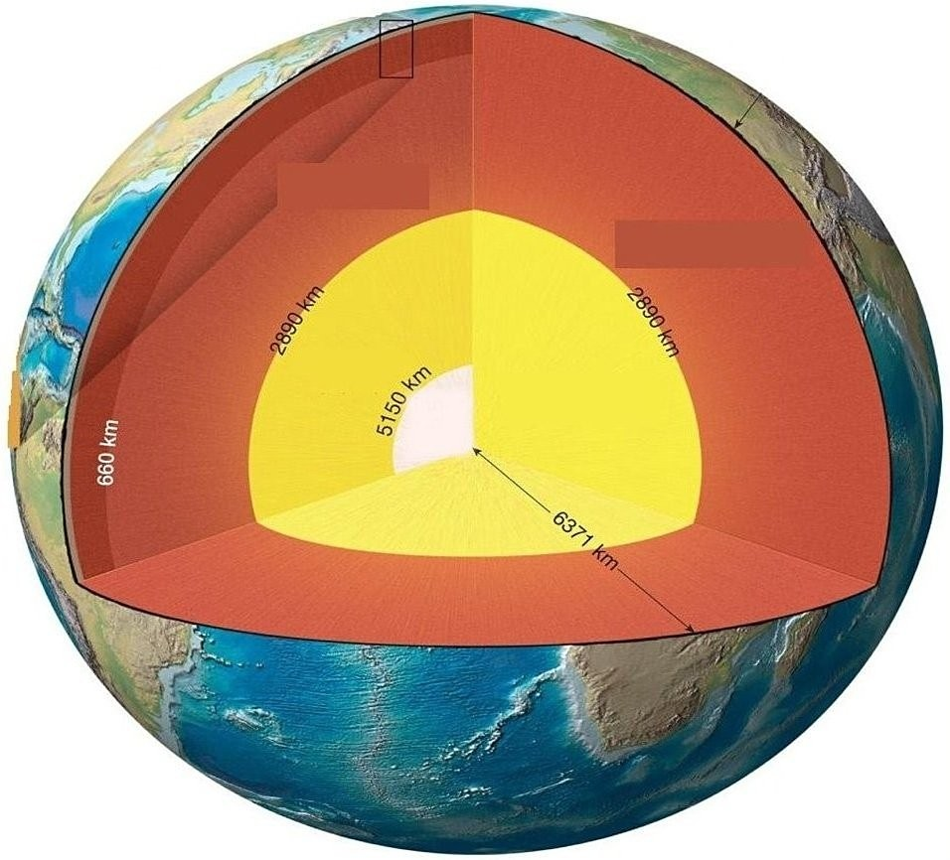
Core
Crust
Mantle
15) Using the following figure, please match each section of the rock cycle to the appropriate label.
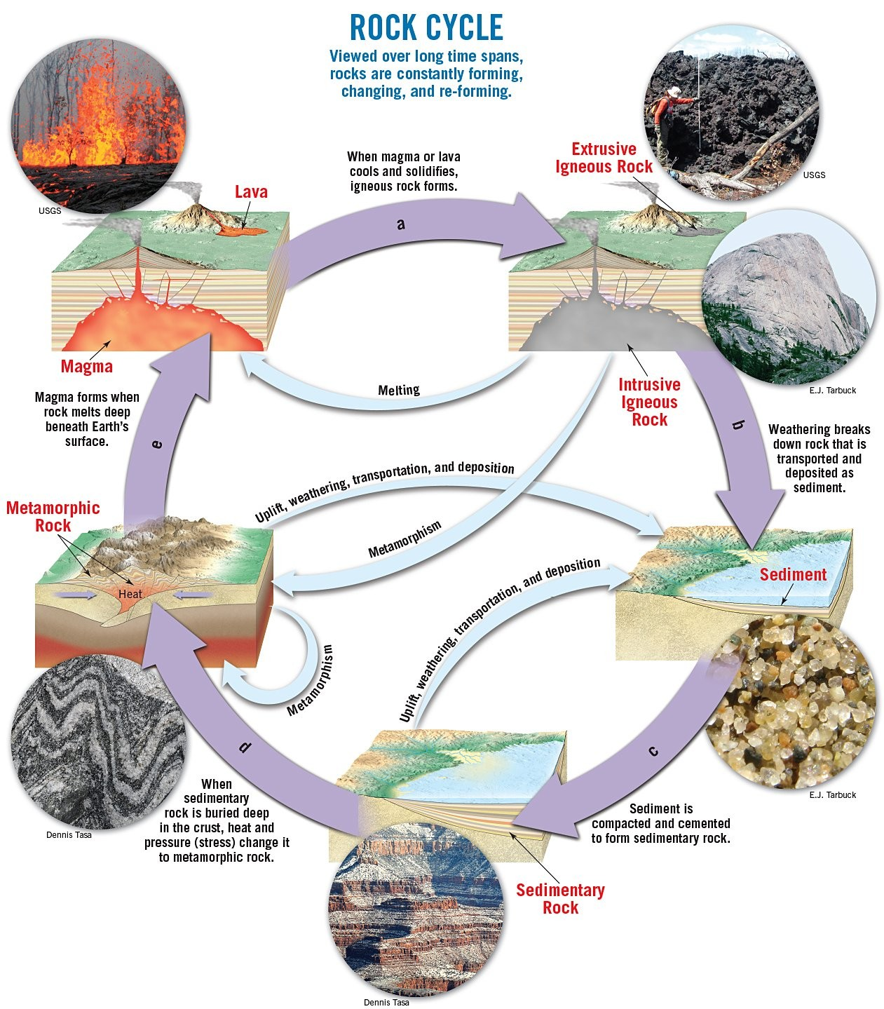
Figure 2: SmartFigure 1.23 of your textbook

Melting
Weathering, transport, deposition
Cooling, crystallization
Lithification
Metamorphism

